CO1-ASSIGNMENT-1
NAME: K R GAYANA
REG NO:192471039
COURSE CODE: CSA0601
COURSE NAME: DESIGN AND ANALYSIS OF ALGORITHMS

Design, Analyse and Validate an Efficient Search Strategy for a Large-Scale Student Record System

TASK 1 – Design Three Search Strategies

1.1 Problem statement
Given a collection of student registration numbers and a target registration number, determine whether the target exists. If it exists, return its index or corresponding value; otherwise, report “Not found.” The methods are Linear Search, Recursive Binary Search and Hash Table Search.

1.2 Strategy A: Iterative Linear Search
Idea: inspect the records one at a time from the first position. Compare each record with the target. Stop immediately when a match is found. If every record has been checked, the target is absent.
Preprocessing: none. The list may be sorted or unsorted.
Step-by-step algorithm:
- Step 1: Set the first index to 0.
- Step 2: Read the value at the current index.
- Step 3: Compare that value with the target registration number.
- Step 4: If equal, return the index and stop.
- Step 5: If not equal, move to the next index.
- Step 6: If the end of the list is reached, return -1 to indicate not found.

Pseudocode
LINEAR_SEARCH(A, key)
for i = 0 to length(A) - 1
if A[i] == key
return i
return -1

1.3 Strategy B: Recursive Binary Search
Idea: use the middle element to decide which half may contain the target. If the target is smaller, recursively search the left half; if larger, recursively search the right half. Only one half is searched.
Preprocessing: the list MUST be sorted in ascending order. If it is not already sorted, sorting must be performed first.
Step-by-step algorithm:
- Step 1: Set low to the first index and high to the last index.
- Step 2: If low > high, the search interval is empty; return -1.
- Step 3: Calculate mid = (low + high) // 2.
- Step 4: If A[mid] equals the target, return mid.
- Step 5: If the target is smaller than A[mid], recursively search low through mid - 1.
- Step 6: Otherwise, recursively search mid + 1 through high.

Pseudocode
BINARY_SEARCH(A, key, low, high)
if low > high
return -1
mid = floor((low + high) / 2)
if A[mid] == key
return mid
else if key < A[mid]
return BINARY_SEARCH(A, key, low, mid - 1)
else
return BINARY_SEARCH(A, key, mid + 1, high)

1.4 Strategy C: Hash Table Search
Idea: store records in a hash table using the registration number as the key. A lookup uses the key to access the matching entry directly on average, instead of scanning the full list.
Preprocessing: construct the dictionary/hash table by inserting the records. Building the table takes Θ(n) time on average and uses Θ(n) additional space. This setup cost should be reported separately from lookup time.
Step-by-step algorithm:
- Step 1: Create an empty hash table.
- Step 2: For each student record, use its registration number as the dictionary key and store its associated record.
- Step 3: To search, check whether the target key exists in the table.
- Step 4: If it exists, return the associated record; otherwise, report not found.

Pseudocode
BUILD_HASH_TABLE(records)
create empty table
for each record in records
table[record.registration_number] = record
return table
HASH_SEARCH(table, key)
if key exists in table
return table[key]
return NOT_FOUND

TASK 2 — Identify the Basic Operation
The basic operation is the operation most directly repeated as the input size grows. Counting it provides a machine-independent way to compare algorithm growth.
Algorithm | Basic operation | Where it occurs | Growth effect
Linear Search | records[i] == key | Once per inspected record | Can reach n comparisons
Binary Search | Compare key with middle item | Each recursive call | Remaining range is halved
Hash Table Search | Dictionary key lookup / key equality | During lookup and collision handling | Expected constant-time lookup

Linear Search operation count
Let C(n) be the number of key comparisons. If the target is at position i using one-based positions, C(n)=i. The best case is one comparison. If the key is last or absent, C(n)=n. Therefore, the worst-case comparison count grows directly with the number of records.

Binary Search operation count
Each recursive call performs one middle-element comparison before either returning or recursing into one half. After each unsuccessful comparison, the active range is approximately half the previous size. The number of comparisons therefore grows with log₂ n, not with n.

Hash Table Search operation count
At the high level, one dictionary lookup is counted as one lookup operation. Internally, a hash table computes a hash and may compare keys when collisions occur. Under normal hashing assumptions, the expected lookup work is Θ(1), while severe collisions can cause Θ(n) work in the theoretical worst case.

Why operation counts are useful
- They allow theoretical comparison without relying on a particular computer.
- They explain why linear search slows as n grows.
- They separate the number of algorithmic operations from noisy wall-clock timings.
- For hashing, report build operations and lookup operations separately.

Worked Comparison and Counting Example

Example dataset
Suppose the sorted Registration Numbers are [101, 105, 110, 115, 120, 125, 130] and the target is 125.

Linear Search
The comparisons are 101, 105, 110, 115, 120, 125. The algorithm uses 6 comparisons. It does not use the sorted property; it simply scans from left to right.

Recursive Binary Search
The first midpoint is index 3, containing 115. Since 125 is larger, the algorithm recurses into the right half. The next midpoint is 125, so it returns. The number of key comparisons is 2.

Hash Table Search
After a table has been constructed, the program calls table.get(125). At the algorithm level, this is one dictionary lookup. Construction is a separate preprocessing operation and must not be hidden when comparing one-off use.
Measurement | Linear | Binary | Hash table
Search operations in example | 6 comparisons | 2 comparisons | 1 high-level lookup
Build/preprocess cost | None | None if already sorted | Dictionary construction required
Data ordering requirement | No | Yes | No
Memory overhead | Low | Low | Additional table storage

Practical measurement warning
The example's operation counts are deterministic for the specified data and target. Actual seconds are not deterministic and can be extremely small. Use repeated measurements for small operations and keep construction time separate from lookup time.

Python check of the worked example
Running the implemented functions from Task 8 on the same dataset and target reproduces the hand-counted values: 6 comparisons for Linear Search, 2 comparisons for Recursive Binary Search and 1 lookup for the hash table.
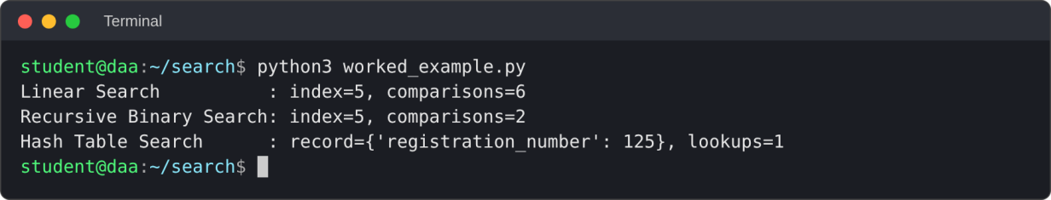
F

TASK 3 – Derive the Time-Complexity Function Mathematically

1. Linear Search
Let n be the number of student records. The basic operation is comparing the target with a record.
- Best case: target is the first record, so C(n) = 1.
- Worst case: target is last or absent, so C(n) = n.
- No preprocessing is needed.
T(n) = c·n + c₀ (worst case)
Ignoring constants and lower-order terms: T(n) = Θ(n). The time grows proportionally to the number of records.

2. Recursive Binary Search
Each call performs constant work and recursively searches at most half of the current records.
T(n) = T(n/2) + c, for n > 1
T(1) = d
After k levels, the remaining number of records is n / 2^k. At termination:
n / 2^k = 1
2^k = n
k = log₂ n
There are logarithmically many levels and constant work per level, so search time is Θ(log n).
Preprocessing: if records are already sorted, the search itself costs Θ(log n). If they must first be sorted using an efficient comparison sort, sorting costs Θ(n log n), so sorting plus one search costs Θ(n log n) + Θ(log n) = Θ(n log n).

3. Hash Table Search
Creating the hash table requires inserting n records.
T_build(n) = Θ(n) on average
Once the table exists, a lookup takes constant time on average.
T_search(n) = Θ(1) on average
Building the table and performing one search costs Θ(n) + Θ(1) = Θ(n) on average.
For q searches after a single build, the expected total cost is Θ(n + q). Worst-case lookup can be Θ(n) if severe collisions occur.

Sorting cost for Binary Search
Binary Search only works correctly when the records are sorted by Registration Number. If the input is already sorted, the search can begin directly. If not, an efficient comparison sort typically costs Θ(n log n).
For one search after sorting: Ttotal(n)=Θ(n log n)+Θ(log n)=Θ(n log n). For q searches after one sorting step: Ttotal(n,q)=Θ(n log n+q log n).

Hash table construction and lookup
Building a dictionary inserts n records. Under average-case assumptions, construction costs Θ(n). After construction, an individual lookup is expected Θ(1), though a theoretical worst-case lookup can be Θ(n). For q lookups after one build, expected total cost is Θ(n+q).
Algorithm | Preprocessing | One search | Total for q searches
Linear Search | None | Θ(n) worst case | Θ(qn) worst case
Binary Search | Θ(n log n) if sorting is needed | Θ(log n) | Θ(n log n + q log n) if sorting is needed
Hash Table | Θ(n) average build | Θ(1) expected | Θ(n + q) expected

Interpretation
- For a single search, building a hash table may cost more than the lookup itself.
- For repeated searches, the initial build can be amortized across many queries.
- If the data is already sorted and must remain ordered, Binary Search can be a practical option.
- A fair report states whether sorting or table construction is included in the reported total.

Assumptions

These results use the standard unit-cost model, where comparisons and basic index operations are constant time. Hash-table average-case results depend on a suitable hash distribution and load management.
TASK 4 — Best, Average and Worst Cases
Algorithm | Best case | Average case | Worst case
Linear Search | Θ(1): first item matches | Θ(n): roughly (n+1)/2 comparisons for equally likely successful positions | Θ(n): last item or absent
Binary Search | Θ(1): middle item matches immediately | Θ(log n) | Θ(log n)
Hash Table Search | Θ(1) | Θ(1) expected | Θ(n) under severe collisions

Linear Search
Best case occurs when the first record matches, so one comparison is enough. Average successful search requires about (n+1)/2 comparisons if target positions are equally likely. Worst case occurs when the key is last or absent, requiring n comparisons.

Binary Search
Best case occurs when the target is at the first midpoint. Otherwise the range is repeatedly halved. The worst-case number of calls is proportional to log₂ n, so average and worst cases are logarithmic.

Hash Table Search
Best and expected average lookup are Θ(1) for a well-behaved table. However, collisions can require additional equality checks. The theoretical worst case is Θ(n), so constant time should be described as expected or average—not guaranteed for every input.

Important distinction
Best/average/worst-case complexity describes how work grows for different inputs or outcomes. It is not the same as an observed timing on one machine. A single benchmark run cannot establish a mathematical complexity bound.
Case Analysis with Example Scenarios

Scenario A: target is first
For Linear Search, the first comparison succeeds and the work is Θ(1). Binary Search may or may not find this item at the first midpoint; if it does not, it continues into the left side. Hash lookup is expected Θ(1) once the table is built.

Scenario B: target is last
Linear Search checks every preceding record and the final record, giving n comparisons. Binary Search repeatedly discards the half that cannot contain the target, so it still needs only logarithmically many comparisons. Hash lookup remains expected constant time after preprocessing.

Scenario C: target is absent
Linear Search must examine every record. Binary Search continues halving the range until the search interval becomes empty. Hash lookup reports that the key is not present; expected lookup remains constant-time under ordinary assumptions.
Input size n | Linear worst-case comparisons | Approx. binary depth
1,000 | 1,000 | 10
10,000 | 10,000 | 14
100,000 | 100,000 | 17
1,000,000 | 1,000,000 | 20
The Binary Search values are approximate log₂ n levels and are theoretical illustrations, not measured runtime values. The exact number of comparisons depends on the target and midpoint path.

Conclusion

For large datasets, Linear Search has the largest worst-case growth. Binary Search is much more efficient than scanning when sorted data is available. Hashing is suitable for repeated exact-key queries, provided memory, build cost, and updates are handled correctly.

TASK 5 — Asymptotic Analysis

Definitions
- Big-O, O(f(n)): an asymptotic upper bound on growth.
- Big-Omega, Ω(f(n)): an asymptotic lower bound on growth.
- Big-Theta, Θ(f(n)): a tight bound when upper and lower growth rates match.
Asymptotic notation describes growth for large input sizes while ignoring constant multipliers and lower-order terms. For example, 5n + 12 is Θ(n), and 3 log₂ n + 7 is Θ(log n).
Algorithm | Best | Average | Worst | Meaning
Linear Search | Θ(1) | Θ(n) | Θ(n) | Work can grow in proportion to record count
Binary Search | Θ(1) | Θ(log n) | Θ(log n) | Slow growth, but sorted input required
Hash Table | Θ(1) | Θ(1) expected | Θ(n) | Fast expected lookup, with collision caveat

Why O, Ω and Θ are not interchangeable
O(f(n)) alone does not claim that the algorithm always takes exactly f(n) work; it states an upper bound. Ω(f(n)) provides a lower bound. Θ(f(n)) is stronger because it describes matching asymptotic upper and lower bounds. Many classroom tables use Θ for a specific best, average, or worst-case growth rate.

Application to this assignment
For worst-case Linear Search, the comparison count is n, so it is Θ(n). Recursive Binary Search performs a logarithmic number of comparisons, so it is Θ(log n). Hash lookup is Θ(1) expected, but its worst-case theoretical bound is Θ(n).

Growth Comparison and Interpretation

Growth rates
n | n (linear work) | log₂ n (binary depth approx.) | Interpretation
1,000 | 1,000 | ≈ 10 | Large difference in comparison count
10,000 | 10,000 | ≈ 14 | Linear work grows tenfold; binary depth adds only a few levels
100,000 | 100,000 | ≈ 17 | Binary search remains logarithmic
1,000,000 | 1,000,000 | ≈ 20 | A million-record scan can be costly

How to read the table
When n increases by a factor of 1,000 from 1,000 to 1,000,000, the linear worst-case comparison count also increases by a factor of 1,000. The logarithm increases from about 10 to about 20. Hash-table lookup is expected to stay approximately constant on average, but its build time and memory usage increase with n.

Complexity versus timing
- Complexity is a model of how work scales as input size grows.
- Timing is an empirical observation affected by machine, operating system, interpreter and system load.
- A logarithmic plot can make trends across several orders of magnitude easier to inspect.
- Do not claim hash lookup is always faster in every one-off case; preprocessing and fixed overhead matter.

Task 5 conclusion
The asymptotic comparison supports hash tables for frequent exact-key lookups, Binary Search for ordered data, and Linear Search as a simple baseline. The choice should also reflect preprocessing, memory, update behaviour and experimental evidence.

TASK 6 — Formulate the Recurrence Relation

Why a recurrence is appropriate
Recursive Binary Search calls itself on a smaller input when the target is not found at the midpoint. Its running time can therefore be expressed in terms of the running time for a smaller problem, plus the work done in the current call.

Define the variables
- T(n): running time for a search interval containing n records.
- n/2: approximate size of the next interval after one half is discarded.
- c: constant work per call, including midpoint calculation and key comparison.
- T(1): constant base-case work when the interval has one record; an empty interval also returns in constant time.

Recurrence relation
T(1) = d, where d is a constant.
T(n) = T(n/2) + c, for n > 1.

Derivation step by step
- A call receives n candidate records.
- It calculates the midpoint and compares the target with the middle record.
- If the key matches, it returns immediately.
- If not, the sorted order tells the algorithm which half can contain the target.
- Only one recursive call is made on at most n/2 records.
- The current call contributes constant work c, producing T(n)=T(n/2)+c.

Assumption
For clean algebra, assume n is a power of two. Floors and ceilings affect the exact number of levels by at most a constant and do not change the Θ(log n) result.

Recurrence Tree and Meaning

Recursion levels
Level | Subproblem size | Work at level
0 | n | c
1 | n/2 | c
2 | n/4 | c
3 | n/8 | c
k | n/2ᵏ | c
There is one recursive call per level. The problem size shrinks by half each time, and the work outside the recursive call remains constant. The recursion tree is therefore a single chain, not a branching tree.

Stopping condition
The recursion stops when n/2ᵏ ≤ 1. Rearranging gives 2ᵏ ≥ n. Taking logarithms gives k ≥ log₂ n. The number of levels is proportional to log n.

Recurrence compared with other algorithms
Algorithm | Recurrence or count | Result
Linear Search | C(n)=n in worst case | Θ(n)
Binary Search | T(n)=T(n/2)+c | Θ(log n)
Hash build | n insertions, average constant work each | Θ(n) build
Hash lookup | Expected constant work per lookup | Θ(1) expected

Common mistake to avoid
Do not write T(n)=2T(n/2)+c for Binary Search. Binary Search does not recursively search both halves; it searches only one. A recurrence with two recursive subproblems describes a different algorithm, such as some divide-and-conquer procedures.

TASK 7 — Solve the Recurrence by Expansion

Given
T(n) = T(n/2) + c, with T(1)=d and c,d constants.

Repeated substitution
T(n) = T(n/2) + c
= [T(n/4) + c] + c
= T(n/4) + 2c
= [T(n/8) + c] + 2c
= T(n/8) + 3c
...
= T(n/2^k) + kc

Determine the number of expansions
Stop when the subproblem size reaches 1:
n / 2ᵏ = 1
n = 2ᵏ
k = log₂ n

Substitute the stopping depth
T(n) = T(1) + c log₂ n
Since T(1)=d, T(n)=d+c log₂ n.
The constants d and c do not affect asymptotic growth. The logarithmic term dominates the growth as n becomes large. Therefore T(n)=Θ(log n).

Interpretation
Each recursive call removes about half the remaining records. Even though the dataset may become much larger, only a small number of additional halving steps are required. This is the mathematical reason Binary Search is efficient for sorted data.

Master Theorem Verification

Master Theorem form
The standard form is T(n)=aT(n/b)+f(n), where a is the number of recursive subproblems, n/b is the size of each subproblem, and f(n) is the work done outside recursion.

Match the Binary Search recurrence
Parameter | Value | Reason
a | 1 | Only one recursive call is made
b | 2 | The search interval is halved
f(n) | Θ(1) | Midpoint and comparison work is constant
n^(log_b a) | n^(log₂ 1)=1 | The comparison term is constant

Apply the equal-growth case
Since f(n)=Θ(1) and n^(log₂ 1)=1, the non-recursive work and the comparison term have the same asymptotic order. The applicable balanced case gives:
T(n)=Θ(log n).

Cross-check
The expansion method produced T(n)=d+c log₂ n. The Master Theorem gives Θ(log n). Both methods agree.

Task 7 conclusion
The recursive Binary Search running time is logarithmic. This conclusion applies to the search phase over sorted records. If the records must first be sorted, the sorting cost must be added to the overall workload.

TASK 8 — Implement and Test the Algorithms
This implementation uses a common dataset for all algorithms, checks correctness, records preprocessing and search time separately, and writes the measurements to a CSV file. It uses the last registration number as the target to expose Linear Search's worst-case behaviour.

Python code — algorithm functions
import csv
import time
import statistics
import platform
import sys
import matplotlib.pyplot as plt

def linear_search(records, key):
comparisons = 0
for i, value in enumerate(records):
comparisons += 1
if value == key:
return i, comparisons
return -1, comparisons

def recursive_binary_search(records, key, low=0, high=None, counter=None):
if high is None:
high = len(records) - 1
if counter is None:
counter = [0]
if low > high:
return -1, counter[0]
mid = (low + high) // 2
counter[0] += 1
if records[mid] == key:
return mid, counter[0]
if key < records[mid]:
return recursive_binary_search(records, key, low, mid - 1, counter)
return recursive_binary_search(records, key, mid + 1, high, counter)

def hash_search(table, key):
return table.get(key, None), 1

def median_time(func, repeats):
"""Run func() several times and return the median duration in seconds."""
samples = []
for _ in range(repeats):
start = time.perf_counter()
func()
samples.append(time.perf_counter() - start)
return statistics.median(samples)

Function notes
- Linear Search returns both the index and the number of comparisons.
- Binary Search uses a shared one-item list to count comparisons across recursive calls.
- Hash lookup returns the record or None and reports one high-level dictionary lookup.
- The code keeps hash-table construction separate from lookup timing.
- median_time() repeats a measurement several times and returns the median, which reduces timer noise.
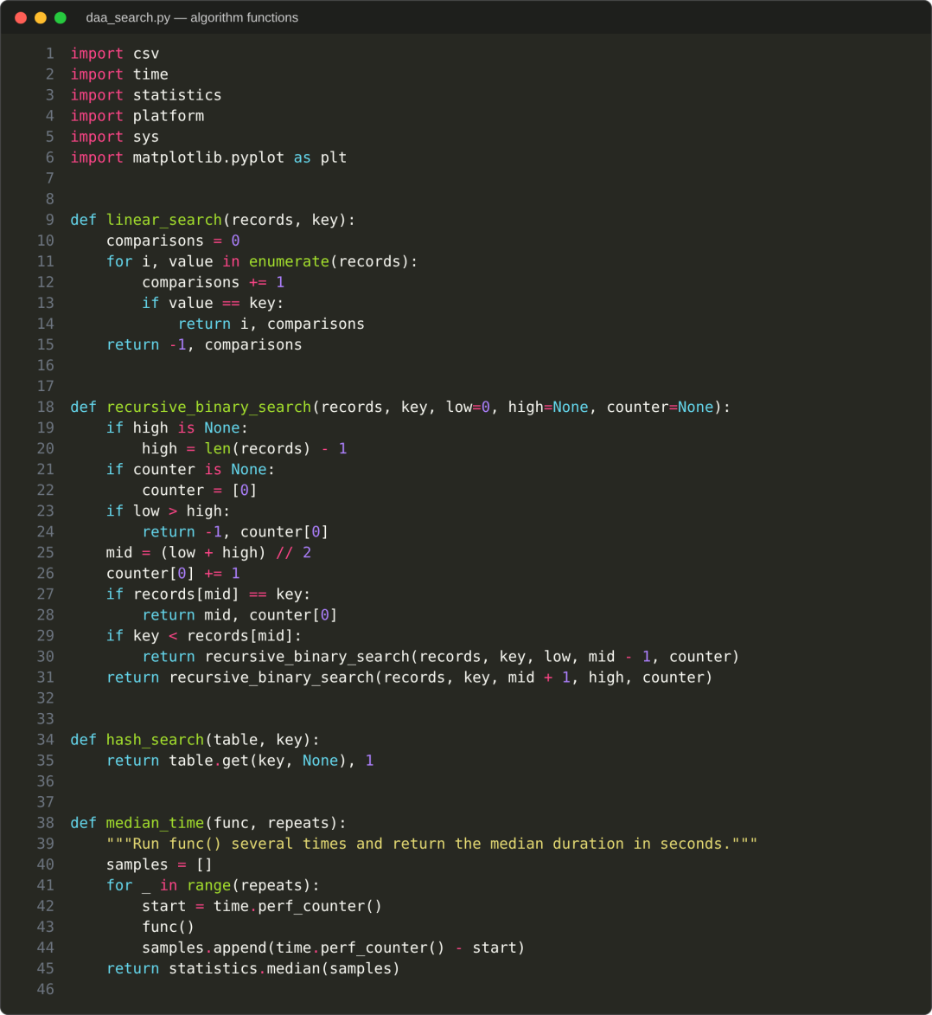
.

Implement and Test the Algorithms

Python code — experiment loop
def main():
sizes = [1_000, 10_000, 100_000, 1_000_000]
results = []

print("Python", sys.version.split()[0], "|", platform.system(), platform.release(),
"|", platform.machine())

for n in sizes:
print(f"\nDataset size: {n:,}")
records = list(range(1, n + 1))
key = records[-1] # last key: worst case for Linear Search

# Linear Search (no preprocessing)
index, comparisons = linear_search(records, key)
assert index == n - 1
linear_seconds = median_time(lambda: linear_search(records, key), 5)
results.append({
"n": n, "algorithm": "Linear Search",
"preprocessing_seconds": 0.0,
"search_seconds": linear_seconds,
"comparisons_or_lookups": comparisons, "found": True
})

# Recursive Binary Search (records already sorted)
index, comparisons = recursive_binary_search(records, key)
assert index == n - 1
binary_seconds = median_time(lambda: recursive_binary_search(records, key), 1000)
results.append({
"n": n, "algorithm": "Recursive Binary Search",
"preprocessing_seconds": 0.0,
"search_seconds": binary_seconds,
"comparisons_or_lookups": comparisons, "found": True
})

# Hash Table Search: build time and lookup time are measured separately
build_seconds = median_time(
lambda: {x: {"registration_number": x} for x in records}, 3)
table = {x: {"registration_number": x} for x in records}
record, lookups = hash_search(table, key)
assert record["registration_number"] == key
hash_seconds = median_time(lambda: hash_search(table, key), 1000)
results.append({
"n": n, "algorithm": "Hash Table Search",
"preprocessing_seconds": build_seconds,
"search_seconds": hash_seconds,
"comparisons_or_lookups": lookups, "found": True
})

for r in results[-3:]:
print(f" {r['algorithm']:<24} "
f"build={r['preprocessing_seconds']:.6f}s "
f"search={r['search_seconds']:.9f}s "
f"count={r['comparisons_or_lookups']:,}")

# Save the measurements to CSV
with open("daa_search_results.csv", "w", newline="") as f:
writer = csv.DictWriter(f, fieldnames=list(results[0].keys()))
writer.writeheader()
writer.writerows(results)
print("\nSaved: daa_search_results.csv")

# Plot search time and operation count against n (log-log axes)
fig, (ax1, ax2) = plt.subplots(1, 2, figsize=(11, 4.2))
for name in ["Linear Search", "Recursive Binary Search", "Hash Table Search"]:
rows = [r for r in results if r["algorithm"] == name]
ax1.plot([r["n"] for r in rows], [r["search_seconds"] for r in rows],
marker="o", label=name)
ax2.plot([r["n"] for r in rows], [r["comparisons_or_lookups"] for r in rows],
marker="o", label=name)
ax1.set_title("Search time vs n")
ax1.set_ylabel("Median search time (seconds)")
ax2.set_title("Comparisons / lookups vs n")
ax2.set_ylabel("Count")
for ax in (ax1, ax2):
ax.set_xscale("log")
ax.set_yscale("log")
ax.set_xlabel("n (number of records)")
ax.grid(True, which="both", alpha=0.3)
ax.legend()
plt.tight_layout()
plt.savefig("daa_search_performance.png", dpi=150)
print("Saved: daa_search_performance.png")

if __name__ == "__main__":
main()
Running python3 daa_search.py (Figure 3) prints the results for each dataset size and saves daa_search_results.csv and daa_search_performance.png. Every timing is the median of repeated runs, and the test environment is listed in Task 9.
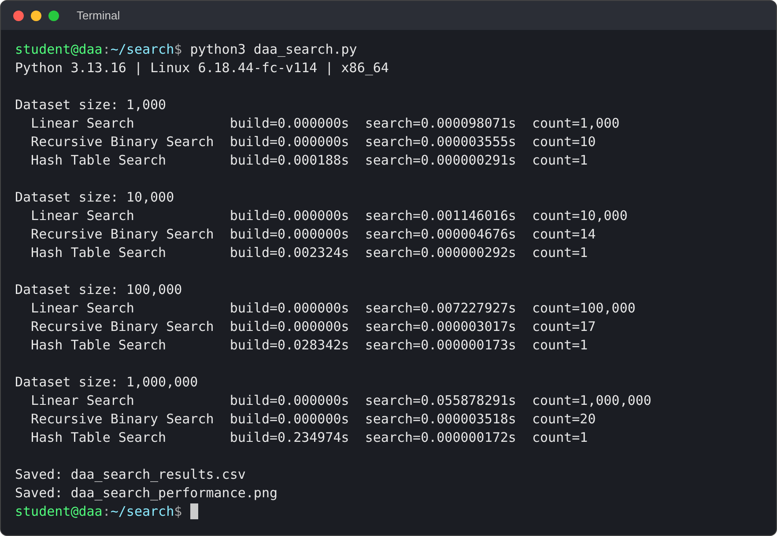

TASK 9 — Record Experimental Performance
Task 9 reports the results of running daa_search.py. All values below are taken from daa_search_results.csv and are rounded to nine decimal places; the CSV holds the full precision. Each time is the median of repeated runs (Linear Search 5 runs, hash build 3 runs, Binary Search and hash lookup 1,000 runs each).

Required experimental conditions
- Use the same dataset sizes for all three algorithms.
- The dataset is generated in sorted order, so Binary Search has no sorting preprocessing in this particular experiment.
- Use the last Registration Number as the target to show Linear Search's worst-case comparison count.
- Record hash table build time separately from hash lookup time.
- Test environment: Python 3.13.16 on Linux 6.18.44 (x86_64) with 2 CPU cores; no other heavy processes were running.
n | Algorithm | Preprocess time (s) | Search time (s) | Count
1,000 | Linear Search | 0 | 0.000098071 | 1,000 comparisons
1,000 | Recursive Binary Search | 0 | 0.000003555 | 10 comparisons
1,000 | Hash Table Search | 0.000187921 | 0.000000291 | 1 lookup
10,000 | Linear Search | 0 | 0.001146016 | 10,000 comparisons
10,000 | Recursive Binary Search | 0 | 0.000004676 | 14 comparisons
10,000 | Hash Table Search | 0.002324320 | 0.000000292 | 1 lookup

Complete the Measurement Table
n | Algorithm | Preprocess time (s) | Search time (s) | Count
100,000 | Linear Search | 0 | 0.007227927 | 100,000 comparisons
100,000 | Recursive Binary Search | 0 | 0.000003017 | 17 comparisons
100,000 | Hash Table Search | 0.028342424 | 0.000000173 | 1 lookup
1,000,000 | Linear Search | 0 | 0.055878291 | 1,000,000 comparisons
1,000,000 | Recursive Binary Search | 0 | 0.000003518 | 20 comparisons
1,000,000 | Hash Table Search | 0.234974402 | 0.000000172 | 1 lookup

Observations
1. As n increases, Linear Search's comparison count equals n (1,000 to 1,000,000) and its median time rises from 0.000098071 s to 0.055878291 s, about 570 times for a 1,000-fold increase in n. The ratio is lower than 1,000 because fixed call overhead dominates the smallest case.
2. Binary Search's comparison count rises slowly (10, 14, 17, 20). Its time stays between 0.000003017 s and 0.000004676 s, so the small differences are Python call overhead and timing noise, not growth with n.
3. Hash-table lookup is one dictionary operation and stays between 0.000000172 s and 0.000000292 s. Construction time grows with n, from 0.000187921 s to 0.234974402 s (about 1,250 times for 1,000 times more records).
4. Because the Binary Search and hash lookups take only microseconds, each was repeated 1,000 times and the median is reported; Linear Search and the hash build were repeated 5 and 3 times.

Evidence: results file and graph
The program saved the measurements to daa_search_results.csv (Figure 4) and the graph to daa_search_performance.png (Figure 5). The values in the tables above match the CSV.
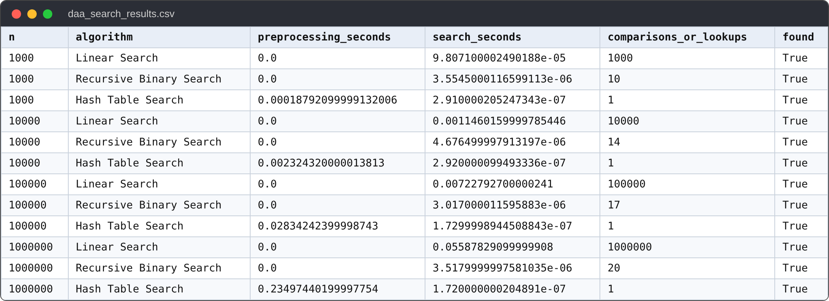

F

TASK 10 — Compare Theory with Experimental Behaviour

Expected theoretical behaviour

Linear Search
For the chosen target at the last position, Linear Search makes n comparisons. As the dataset grows from 1,000 to 1,000,000, its comparison count increases by a factor of 1,000. Its measured time should generally rise with n, although exact ratios are affected by implementation and hardware.

Recursive Binary Search
Binary Search performs a logarithmic number of comparisons. The data in this experiment is already sorted. The number of levels increases slowly as n grows, so search time should generally grow much more slowly than Linear Search.

Hash Table Search
Dictionary lookup is expected to be approximately constant time on average after the table is built. The construction phase requires Θ(n) average work and extra memory. A fair comparison distinguishes lookup-only time from build-plus-lookup time.

Why observed values may differ
- Interpreter overhead and function-call cost.
- CPU caching and memory layout.
- Memory allocation and garbage collection.
- Operating-system scheduling and background processes.
- Timer resolution and very short measured durations.
Write an Evidence-Based Comparison

Evidence-based analysis
As n increased from 1,000 to 1,000,000, the measured Linear Search time rose from 0.000098071 s to 0.055878291 s (about 570 times), growing roughly in proportion to n.
The Recursive Binary Search time stayed between 0.000003017 s and 0.000004676 s while its comparison count rose only from 10 to 20.
Hash lookup time stayed between 0.000000172 s and 0.000000292 s, while table construction required 0.000187921 s for n = 1,000 and 0.234974402 s for n = 1,000,000.
These observations agree with theoretical growth rates because Linear Search scales as Θ(n), Binary Search as Θ(log n), and hash lookup is expected Θ(1) after a Θ(n) build.

Comparison table
Claim | Evidence to cite | Your conclusion
Linear Search grows linearly | Comparison counts and measured times in CSV | Supported: comparisons equal n and the median time grows about 570 times when n grows 1,000 times.
Binary Search grows logarithmically | Comparison counts and graph trend | Supported: comparisons grow only from 10 to 20; the time stays at a few microseconds.
Hash lookup is expected Θ(1) | Lookup time and separately reported build time | Supported: lookup time is flat at about 0.0000002 s; the build cost is reported separately.
Preprocessing affects total cost | Hash build timing; sorting assumption for Binary Search | Supported: the hash table needs 0.234974402 s to build at n = 1,000,000, which a one-off search would not recover.

Recommended discussion
The graph (Figure 5) shows Linear Search as a steep rising line, Binary Search almost flat and the hash lookup lowest and flat. The exact values are in the CSV (Figure 4). A few timings are tiny, so the graph shows the overall trend and the comparison counts provide the exact growth.

Task 10 conclusion
The measured results match the predictions of Tasks 3 to 5. The small non-monotonic differences, such as Binary Search at n = 10,000 being slightly slower than at n = 100,000, come from timer resolution, interpreter overhead and caching, not from the algorithm.

TASK 11 — Recommend and Defend the Final Design

Recommendation
For frequent exact lookups by unique Registration Number, use a hash table (such as a Python dictionary or an equivalent indexed data structure) as the primary lookup mechanism, provided memory testing and real performance measurements support deployment.

Technical justification
Factor | Hash-table design implication
Average lookup | Expected Θ(1), suitable for frequent exact-key searches
Initial build | Θ(n) average; can be amortized over many lookups
Daily updates | Each insertion is typically Θ(1) average
Memory | Additional storage is needed for the index
Worst-case limitation | Θ(n) lookup can occur in theoretical collision-heavy cases
Data ordering | Does not naturally replace a sorted index for range queries

Why not Linear Search as the primary design?
A worst-case search may inspect all one million records. With many queries, the repeated work becomes expensive. Linear Search is still useful as a correctness baseline and may be acceptable for very small datasets or rare lookups.

When Binary Search remains useful
Binary Search is appropriate when the records are already sorted, ordered traversal is important, or range queries are needed. Its search time is Θ(log n), but sorted order must be maintained and sorting cost must be counted when it is required.

Operational Safeguards and Final Defence

Production considerations
- Validate incoming Registration Numbers and reject malformed values.
- Enforce uniqueness and define what happens if a duplicate key is submitted.
- Persist the source of truth so the in-memory index can be rebuilt after restart.
- Update the index only after the new record is validated and successfully stored.
- Consider concurrent requests, error handling, monitoring and recovery.
- Measure memory usage with one million realistic records on the target machine.

Evidence-based defence
In the experiment at n = 1,000,000 the hash lookup took 0.000000172 s, compared with Binary Search and Linear Search at 0.000003518 s and 0.055878291 s. The hash table needed 0.234974402 s to build once, and the index for 1,000,000 records used about 215.5 MB of memory (Figure 6). The cost of building the index is therefore included in the recommendation, not hidden.
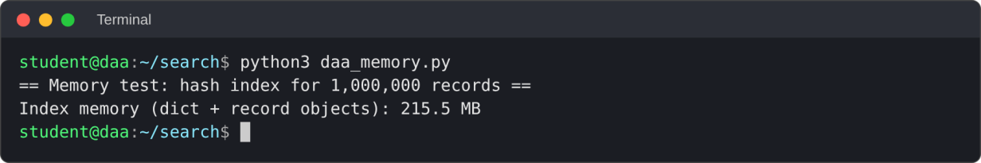

Decision matrix
Requirement | Preferred strategy | Reason
Simple baseline / unsorted data | Linear Search | No preprocessing; straightforward
Sorted records / ordered traversal | Binary Search plus sorted index | Θ(log n) exact lookup
Frequent exact-key queries | Hash table | Expected Θ(1) lookup after build
Range queries / sequential reporting | Sorted structure | Hashing does not preserve order

Final defence paragraph
I recommend a hash table (Python dictionary) because the workload requires frequent exact lookups by unique Registration Number. In my experiment, the result table shows a lookup of 0.000000172 s at n = 1,000,000 against 0.055878291 s for Linear Search. The preprocessing cost was 0.234974402 s once, and the memory/update considerations are about 215.5 MB of index memory and Θ(1) average insertion after duplicate validation. Binary Search remains an alternative when the records are already sorted and ordered traversal or range queries are needed.

TASK 12 — Re-evaluate the Design: Day-4 Challenge

Revised workload
The revised workload is 50,000 searches per hour against 1,000,000 records. New records are added only once per day. This means the system is read-heavy: many searches occur between relatively infrequent updates.

A. Impact analysis
Average search request rate = 50,000 / 3,600 ≈ 13.89 searches per second. This average rate is not necessarily the peak rate; the real deployment should also consider bursts and concurrency.

Implications
- A reusable index is preferable to scanning the full dataset for each request.
- Rebuilding the index for every search would repeat Θ(n) work unnecessarily.
- The initial build cost can be amortized across the large number of queries.
- Daily new records can usually be inserted into the existing hash table after validation.
- Memory, restart recovery, concurrency and monitoring become system-level requirements.

Estimate the extreme Linear Search work
If every request scans all one million records, the extreme count is 50,000 × 1,000,000 = 50,000,000,000 record comparisons per hour. This is a theoretical upper scenario for last-or-absent keys, not a measured workload prediction.
This estimate was checked by running the workload with 50,000 random registration numbers against 1,000,000 records (Figure 7). The hash table finished the 50,000 lookups in 0.051 s (1.01 microseconds each) and Binary Search in 0.332 s. Linear Search needed 5.976 s for only 200 searches, which extrapolates to about 1494 s (25 minutes) of CPU time for the 50,000 searches of one hour and roughly 30 ms per request.
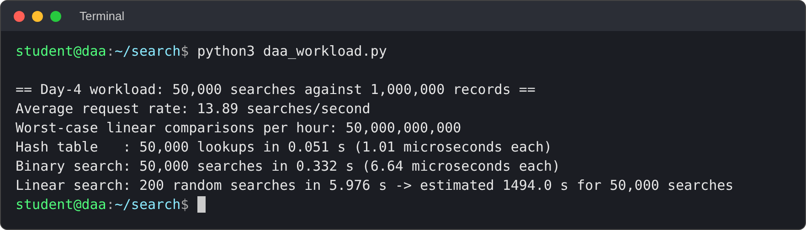

Design question
The central question is whether to retain the original strategy, replace it, or adapt it to handle many repeated searches and daily updates reliably.

Evaluate and Adapt the Design

B. Evaluate the original design
The hash-table approach remains suitable because it can be built once and reused. Its expected exact-key lookup cost is Θ(1), compared with Θ(n) worst-case work for Linear Search and Θ(log n) for Binary Search over sorted records.

C. Adaptation or redesign
Decision: retain the hash-table strategy but improve its operational design. Load the one million records into a dictionary keyed by Registration Number, validate uniqueness, perform lookups through the index, and insert each daily new record after validation.

Recommended update flow
- Receive the new student record.
- Validate the Registration Number and required fields.
- Check that the key does not already exist.
- Persist the record in the authoritative data store.
- Insert the key and record into the in-memory hash index.
- Log success or failure and monitor index consistency.
- On restart, reload or rebuild the index from the source of truth.

Cost summary
Operation | Expected cost
Initial hash-table build | Θ(n) average
Each exact lookup after build | Θ(1) average; Θ(n) theoretical worst case
Each daily insertion | Θ(1) average per record
q searches after one build | Θ(n + q) expected total, excluding storage-system overhead

Evidence-Based Defence and Final Decision

D. Evidence-based defence
With one million records and 50,000 searches per hour, repeated sequential scanning can produce up to 50 billion record comparisons per hour in the extreme last-or-absent-key scenario. A hash table is expected to perform constant-time lookup after the initial build, making it a better fit for repeated exact-key queries under normal hashing assumptions.

Risks and mitigations
Risk | Mitigation
Memory usage too high | Measure memory with realistic records; size the deployment machine appropriately
Duplicate Registration Numbers | Validate uniqueness before inserting
Index becomes inconsistent | Persist authoritative data; use controlled updates and recovery checks
Traffic bursts exceed average rate | Load-test concurrent queries and measure response-time percentiles
Hashing worst-case behaviour | Use a trusted implementation, monitor latency and test realistic keys
Restart or process failure | Rebuild index from persistent source of truth

Final decision
Retain Hash Table Search as the primary exact-registration-number lookup. Keep Binary Search or a sorted index when ordered traversal and range queries are important. Do not use theoretical complexity alone as the deployment sign-off: confirm response times, memory usage, update correctness and concurrency behaviour with realistic testing.

Challenge conclusion
The revised workload strengthens the case for a reusable index. The important adaptation is not merely selecting hashing, but ensuring that the index is safely built, updated, persisted or recoverable, monitored and tested under realistic conditions.

APPENDIX A — Test Plan, Result Interpretation and Submission Checklist

Suggested test cases
Test | Input / target | Expected result
Successful: first key | key = 1 | All algorithms return first record/index
Successful: middle key | key = n//2 | All algorithms return matching record/index
Successful: last key | key = n | Linear Search worst-case comparisons = n
Unsuccessful search | key = n+10 | Linear/Binary return -1; hash returns None
Small empty dataset | records = [] | All algorithms report not found safely
Duplicate key input | Two records share one key | Validation rejects or explicitly resolves duplicate

Test run output
All six test cases pass for the three algorithms; the worked example from Task 2 and the duplicate-key rule were checked in the same run.
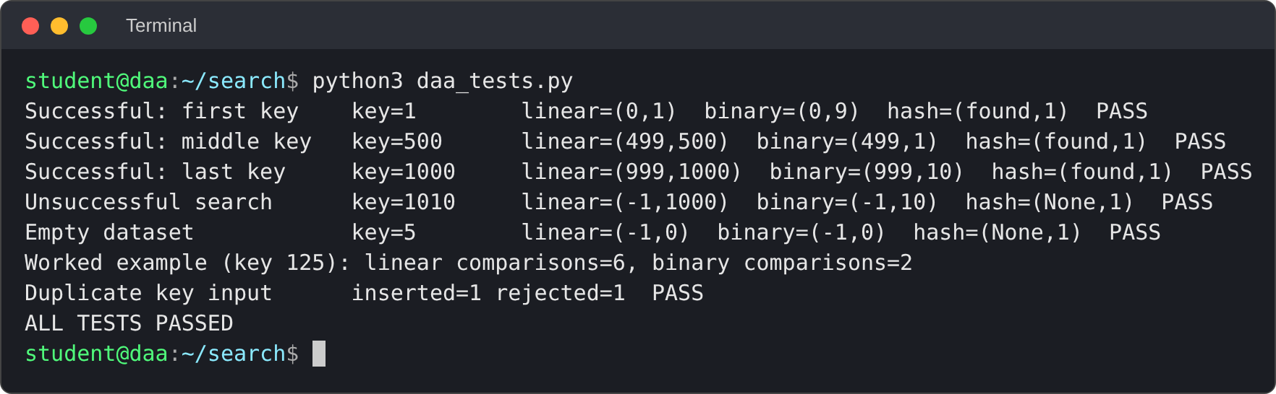
.

Interpretation checklist
- Confirm all three algorithms return the correct record.
- Use the same target and data size when comparing algorithms.
- Record preprocessing time separately.
- Use actual measured values and attach the CSV and graph.
- Explain whether data was already sorted.
- Avoid claims that a single experiment proves theoretical complexity.
APPENDIX B — Formula Sheet and Overall Conclusion

Formula sheet
Concept | Formula / result
Linear Search worst case | C(n)=n; T(n)=Θ(n)
Linear Search successful average | (1+2+…+n)/n = (n+1)/2 = Θ(n)
Binary Search recurrence | T(n)=T(n/2)+c
Binary Search solution | T(n)=d+c log₂ n = Θ(log n)
Binary Search with sorting | Θ(n log n + q log n) for q searches
Hash-table build | Θ(n) expected
Hash-table lookup | Θ(1) expected; Θ(n) theoretical worst case
q hash lookups after build | Θ(n+q) expected

Overall conclusion
This assignment compares three search strategies for a student-record system. Linear Search is easy and does not require preprocessing, but its work grows linearly in the worst case. Recursive Binary Search reduces the search interval by half and has Θ(log n) search time, provided the records are sorted. Hash Table Search requires Θ(n) expected preprocessing and additional memory, then offers expected Θ(1) exact-key lookups.
The mathematical analysis explains the expected scaling, while the experiment measures one implementation on one computer. The final recommendation should consider both forms of evidence, along with preprocessing, memory, update frequency, data ordering and operational reliability. For the read-heavy challenge of 50,000 searches per hour against one million records, a reusable hash-table index is the preferred starting design, subject to testing.

